Mr. Sabado, Algebra 2 Monday, October 28, 2013

Homework

Due Today:
Class Work: Chapter 4 Review Stations

Due 10/29:
Chapter 4 Test Review #2


Presentations will be held Thursday and Friday.

Agenda

- Pick-up Calendars
- Warm-Up

- Review: Write Quadratic in Standard Form

- Exit Ticket: Chapter 4 Review Stations

- Homework

Warm-Up
Solve
- 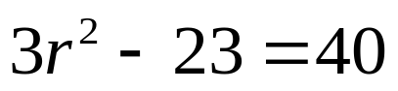

Simplify
2)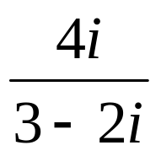
`
whs.saba.do



“It is never too late to be what you might have been.”
- G. Eliot

